CREATE DATABASE employeesdb;
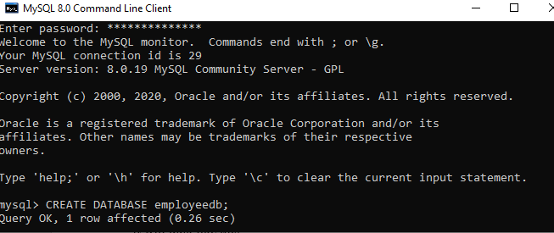

2. SHOW DATABASES;
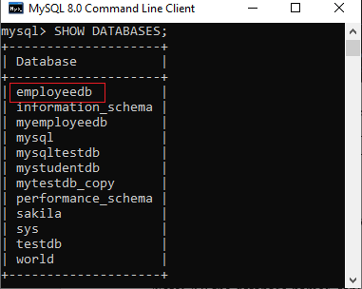
3. USE emplyeedb;
You can start executing the command.
CREATE TABLE table_name( column_definition1, column_definition2, ........, );
Ex : create table student (id int(5),name varchar(15),address char(15), semester int(2), age int(2));

INSERT INTO student (id, name, address, semester,age)
VALUES (101, 'Peter', 'Malleshwaram', 2,25);

UPDATE
The UPDATE statement is used with the SET and WHERE clauses. The SET clause is used to change the values of the specified column. We can update single or multiple columns at a time.
UPDATE table_name SET column_name1 = new-value1, column_name2=new-value2, ... [WHERE Clause]

Ex: UPDATE students SET Name = 'beinghuman' WHERE Id = '3' ;

Updating Multiple Fields:
UPDATE students SET FirstName = 'xyz', last_Name = 'Johnny' WHERE Student_Id = '3

ALTER
MySQL ALTER statement is used when you want to change the name of your table or any table field. It is also used to add or delete an existing column in a table.

ADD a column in the table
ALTER TABLE table_name ADD new_column_name column_definition [ FIRST | AFTER column_name ];
ALTER TABLE student ADD birthdate int(2);

Add multiple columns in the table
ALTER TABLE table_name ADD new_column_name column_definition
[ FIRST | AFTER column_name ],
ADD new_column_name column_definition [ FIRST | AFTER column_name ],
... ;

MODIFY column in the table
ALTER TABLE table_name
MODIFY column_name column_definition
[ FIRST | AFTER column_name ];

ALTER TABLE Student MODIFY studsurname varchar(50) ; ____> it modifies the datatype size or datatype

DROP column in table
ALTER TABLE table_name DROP COLUMN column_name;

ALTER TABLE student DROP COLUMN address;

RENAME column in table
ALTER TABLE table_name
CHANGE COLUMN old_name new_name
column_definition
[ FIRST | AFTER column_name ]

ALTER TABLE student CHANGE COLUMN studsurname studtitle varchar(20) ;

RENAME table
ALTER TABLE table_name RENAME TO new_table_name;

In this example, the table name cus_tbl is renamed as cus_table.
- ALTER TABLE cus_tbl
- RENAME TO cus_table;

SELECT COMMAND

- Select * from tablename;

- Retrieval of specific columns from a table
Syn select columnname, columname from tablename;

Select stid,name from student;
- Elimination of duplicates from the select statement

Select distinct columname ,Colum name from tablename;

Select distinct stuid, name, age from student;

- Selecting a data set from table data

Select columname,columname from tablename where search conditions
=,>,<<=,>=,Between,Like,in

Select * from student where address = ‘Bangalore’;

Logical operators
AND,OR
Select * from student where firstname=’megha’ and lastname =’yukta’;

Select * from student where firstname=’megha’ or lastname =’yukta’;

